Name: Akhilesh Munishwar
PRN: 1262242269
Roll no.: 28
Panel: G

School of Computer Science and Engineering
Department of Computer Engineering and Technology
T. Y. B. Tech CSE
AY 2026-27 Semester V
Computer Networks Lab (CSE20110)
Assignment No.: 2
Title: Implement Error Control Protocol (error detection and correction using Hamming code)
Objectives:
- To encode and decode original data bits with the help of parity bits.
- To demonstrate the use of error control protocols in data communication.
Theory
1. Types of Errors
While data is transmitted from a sender to a receiver over a communication channel, the signal can get distorted because of noise, interference or attenuation. Because of this the bits received may not be the same as the bits sent. Broadly, these errors are classified into two types.
- Single-bit error: Only one bit in the entire data unit has changed from 0 to 1 or from 1 to 0. This type of error usually occurs when the noise is short-lived and affects only one bit position.
- Burst error: Two or more consecutive bits in the data unit are changed. Burst errors are common in serial transmission and the length of the burst is measured from the first to the last corrupted bit.
Error control techniques are broadly divided into error detection (checksum, CRC, parity check) and error correction (Hamming code), the latter locating and fixing the error at the receiver end itself.
2. Concept of Parity Bits
A parity bit is an extra bit added to a group of data bits so that the total number of 1s in the group becomes either even (even parity) or odd (odd parity). Before transmission, the sender calculates the parity bit and appends it to the data. At the receiver side, the parity is recalculated over the received bits; if it does not match the expected parity, an error is flagged.
A single parity bit can only detect an odd number of bit errors and cannot indicate which bit is wrong. Hamming code overcomes this by using multiple parity bits placed at specific positions, which together point to the exact position of a single-bit error and correct it.
3. Hamming Code Example (Transmitter and Receiver Side)
Consider a 4-bit data word 1011 that needs to be sent using a (7,4) Hamming code. Since the number of parity bits r must satisfy 2^r >= m + r + 1 (m = 4), we need r = 3 parity bits. The resulting codeword is 7 bits long, with parity bits placed at positions 1, 2 and 4 (powers of two) and data bits placed at positions 3, 5, 6 and 7.
Bit Position | 1 | 2 | 3 | 4 | 5 | 6 | 7
Type of bit | P1 | P2 | d1 | P4 | d2 | d3 | d4
Value | 0 | 1 | 1 | 0 | 0 | 1 | 1
Transmitter side - calculating the parity bits (even parity is used, so each parity bit covers positions that include it and its group):
- P1 covers positions 1, 3, 5, 7 → 1 + 0 + 1 = even → P1 = 0
- P2 covers positions 2, 3, 6, 7 → 1 + 1 + 1 = odd → P2 = 1
- P4 covers positions 4, 5, 6, 7 → 0 + 1 + 1 = even → P4 = 0
The transmitted codeword therefore becomes: 0 1 1 0 0 1 1
Receiver side - suppose bit 5 gets flipped during transmission due to noise, so the received codeword is 0 1 1 0 1 1 1. The receiver recomputes three check bits C1, C2 and C4 in the same way as the parity bits:
- C1 = position1 ⊕ position3 ⊕ position5 ⊕ position7 = 0 ⊕ 1 ⊕ 1 ⊕ 1 = 1
- C2 = position2 ⊕ position3 ⊕ position6 ⊕ position7 = 1 ⊕ 1 ⊕ 1 ⊕ 1 = 0
- C4 = position4 ⊕ position5 ⊕ position6 ⊕ position7 = 0 ⊕ 1 ⊕ 1 ⊕ 1 = 1
The error position is found from the binary number C4 C2 C1 = 1 0 1 = 5 (decimal), which correctly points to the 5th bit as the corrupted one. The receiver simply flips bit 5 back to recover the original codeword 0 1 1 0 0 1 1, and the original data 1011 is extracted from positions 3, 5, 6 and 7.
Design Screenshots
Not applicable for this assignment.
Program Code
The following C program encodes 4 data bits into a 7-bit Hamming codeword, allows an error to be introduced on the receiver side, and then detects and corrects a single-bit error.
#include <iostream>

using namespace std;

// Function to generate the Hamming Code using pointer arithmetic
void generateHammingCode(int* data, int* hamming) {
// Place data bits at non-power-of-2 positions: 3, 5, 6, 7
*(hamming + 3) = *(data + 0);
*(hamming + 5) = *(data + 1);
*(hamming + 6) = *(data + 2);
*(hamming + 7) = *(data + 3);

// Calculate parity bits using XOR for Even Parity
*(hamming + 1) = *(hamming + 3) ^ *(hamming + 5) ^ *(hamming + 7);
*(hamming + 2) = *(hamming + 3) ^ *(hamming + 6) ^ *(hamming + 7);
*(hamming + 4) = *(hamming + 5) ^ *(hamming + 6) ^ *(hamming + 7);
}

// Function to detect and correct single-bit errors
void detectAndCorrectError(int* received) {
// Calculate syndrome bits
int c1 = *(received + 1) ^ *(received + 3) ^ *(received + 5) ^ *(received + 7);
int c2 = *(received + 2) ^ *(received + 3) ^ *(received + 6) ^ *(received + 7);
int c4 = *(received + 4) ^ *(received + 5) ^ *(received + 6) ^ *(received + 7);

// Calculate error position
int errorPosition = c4 * 4 + c2 * 2 + c1 * 1;

if (errorPosition == 0) {
cout << "\n[Status] No error detected in the received data.\n";
} else {
cout << "\n[Status] Error detected at position " << errorPosition << ".\n";

// Correct the error by flipping the bit using pointer arithmetic
*(received + errorPosition) = *(received + errorPosition) == 0 ? 1 : 0;

cout << "[Status] Error automatically corrected.\n";
}
}

int main() {
int data[4];
// Array size 8 used to allow 1-based indexing (index 0 is ignored)
int hamming[8] = {0};

cout << "--- Hamming Code (7,4) Sender ---\n";
cout << "Enter 4 data bits one by one (space separated): ";
for (int i = 0; i < 4; i++) {
cin >> *(data + i);
}

generateHammingCode(data, hamming);

cout << "Transmitted Hamming Code: ";
for (int i = 1; i <= 7; i++) {
cout << *(hamming + i) << " ";
}
cout << "\n\n";

// --- Simulating Receiver ---
int received[8];
cout << "--- Hamming Code (7,4) Receiver ---\n";
cout << "Enter the 7 received bits one by one (introduce an error to test): ";
for (int i = 1; i <= 7; i++) {
cin >> *(received + i);
}

detectAndCorrectError(received);

cout << "Corrected / Validated Hamming Code: ";
for (int i = 1; i <= 7; i++) {
cout << *(received + i) << " ";
}
cout << "\n";

return 0;
}
Output Screenshots
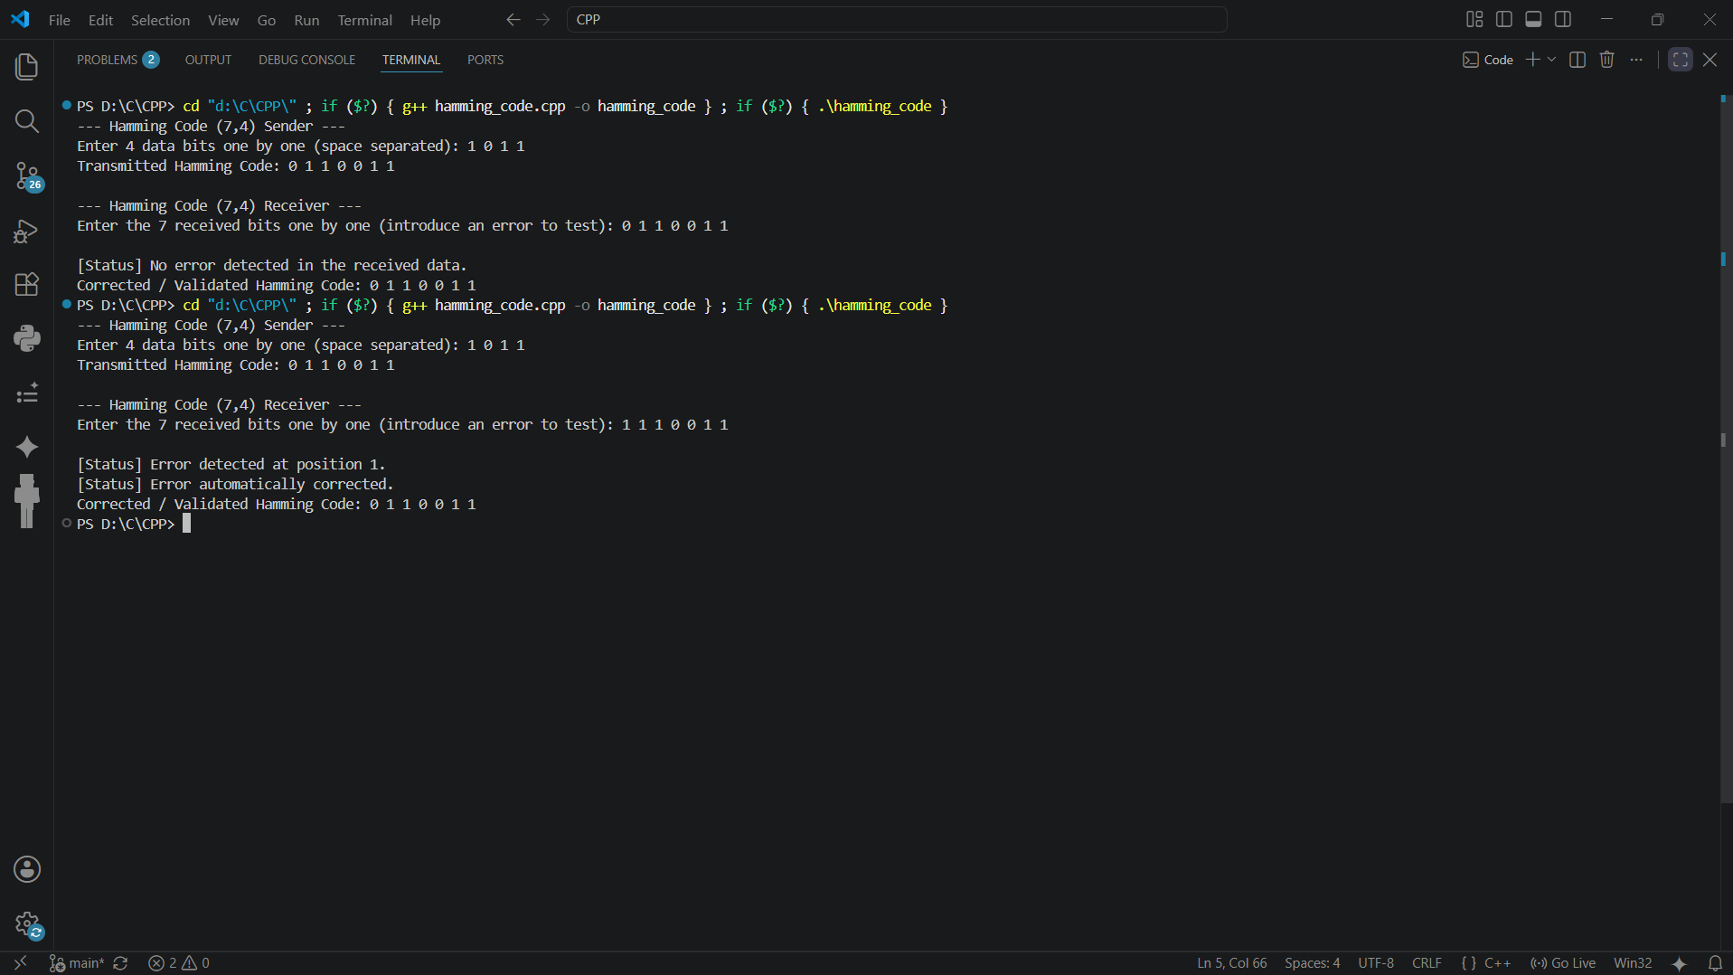

Students Observation
From this assignment I understood how a single parity bit is only able to tell us that an error has occurred but cannot tell where it has occurred, and it also fails when two bits get flipped at the same time. Implementing the Hamming code helped me see how placing parity bits at power-of-two positions makes it possible to point exactly at the corrupted bit using simple XOR operations, and correct it without asking for retransmission. I also observed that the same logic used at the transmitter side to generate the parity bits is reused at the receiver side to recompute the check bits, which makes the algorithm simple to implement in code. Overall the Hamming code gives a good balance between the number of extra bits added and the error correcting capability it provides for single-bit errors.
FAQ
1) What is the difference between flow control and error control?
Flow control makes sure that a fast sender does not overwhelm a slow receiver by regulating the amount and the rate of data that is sent, using techniques such as stop-and-wait or sliding window. Error control, on the other hand, is concerned with detecting and correcting/retransmitting data that gets corrupted or lost during transmission, using techniques such as parity check, checksum, CRC and Hamming code. In short, flow control manages the speed of data transfer, while error control manages the reliability and correctness of the data being transferred.

2) Explain in brief two types of error control mechanisms.
- Error Detection: The receiver is only able to find out that an error has occurred in the received data; it cannot correct the error itself, so the corrupted frame is usually discarded and a retransmission is requested. Checksum and Cyclic Redundancy Check (CRC) are common error detection techniques.
- Error Correction: The receiver is able to not only detect that an error has occurred but also identify exactly which bit(s) are wrong and correct them without needing a retransmission. Hamming code is a widely used error correction technique that achieves this using multiple parity bits.

3) Calculate Checksum for (7, 11, 12, 0, 6)
Step 1: Represent each number in 8-bit binary form.
Number | 7 | 11 | 12 | 0 | 6
8-bit binary | 00000111 | 00001011 | 00001100 | 00000000 | 00000110
Step 2: Add all the numbers together using binary addition with end-around carry.
7 + 11 + 12 + 0 + 6 = 36 → 00100100 (no overflow beyond 8 bits, so no carry to add back)
Step 3: The checksum is the 1's complement of this sum.
Sum = 00100100 → Checksum = 11011011
Verification at the receiver: add all the original numbers along with the checksum. If the result is all 1s (11111111), the data is accepted as correct: 00100100 + 11011011 = 11111111 ✓

4) Calculate CRC for 100100 with key 1101. Also prove that the received data is correct.
Step 1: The key 1101 has 4 bits, so r = 3 zeros are appended to the data before division.
Data with appended zeros: 100100 000 = 100100000
Step 2: Divide this value by the key 1101 using binary (XOR) division. The successive XOR steps are:
- 1001 ⊕ 1101 = 0100 → bring down next bit → 1000
- 1000 ⊕ 1101 = 0101 → bring down next bit → 1010
- 1010 ⊕ 1101 = 0111 → bring down next bit → 1110
- 1110 ⊕ 1101 = 0011 → bring down next bit → 0110
- 0110 → leading bit is 0, no XOR → remainder = 001
Step 3: The remainder 001 (CRC) is appended to the original data to form the transmitted codeword:
Transmitted codeword = 100100 + 001 = 100100001
Proof at the receiver side: the received codeword 100100001 is divided by the same key 1101. If the remainder comes out to be 000, the data is accepted as error-free. Dividing step by step: 1001⊕1101=0100 → 1000 → 1000⊕1101=0101 → 1010 → 1010⊕1101=0111 → 0111 → 0111⊕1101=1010 → 0101 → leading bit 0, no XOR → remainder = 000.
Since the remainder is 000, the received data 100100001 is confirmed to be correct.

